Calculation of carbon dioxide emissions avoided
“Mainstreaming biodiversity conservation and sustainable landscape management of watersheds containing wetlands within Chile's South Center Biodiversity Hotspot through reformed coastal planning frameworks”
The EX‐Ante Carbon Balance Tool - EX‐ACT
The carbon benefits from the project are estimated in terms of lifetime direct as well as consequential GHG emissions avoided over a time horizon of 20 years. For this project, the duration of the implementation phase and the capitalization phase are defined as five years and 15 years, respectively. The carbon benefits are calculated using EX‐Ante Carbon Balance Tool - EX‐ACT (http://www.fao.org/tc/exact/ex-act-home/en/). This is a land-based accounting system, estimating C stock changes (i.e., emissions or sinks of CO2) as well as GHG emissions per unit of land, expressed in equivalent tons of CO2 per hectare and year. This tool has been widely used in the assessment of implications of land use and land cover changes around the world and continue to serve as a policy and decision support tool for land use planning at different geographical scales. For this project, the Ex-Ante tool is used to compute land use changes, Management Degradation and Coastal Wetlands avoided emissions that will result from the project interventions (see Figure 1 for the set-up of the Ex_ACT tool for this computation)

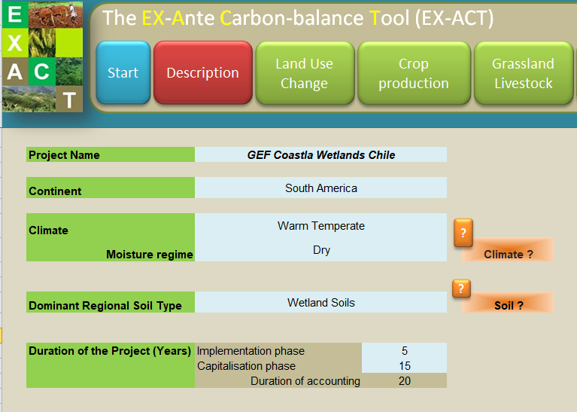
Figure 1. Background information for computing carbon emissions savings for GEF Coastal Wetlands Chile
Parameterization of the model
The main sources of direct carbon emissions avoidance in this project will be on forest restoration activities, restoration of degraded agricultural land, and wetlands conservation, which will be carried out in the five demonstrative landscapes in the Meditarrean Ecoregion of Chile.
Carbon emissions avoidance coming from Land use Change, will come from afforested or reforested degraded land of the pilot wetlands watersheds, reaching at least 10,500 ha. In terms Emission avoided from Management Degradation, 10,000 ha will reduce the level of degradation from large to moderate, due to project activities of the Integral Management Plans. At the wetlands level, the trends for the 500 ha of wetlands due to population pressure and construction are high, therefore a conservative estimate is that there will still be some impacts due to excavation and drainage, but the trend will be reduced from 35% to 5% with project implementation.
Results
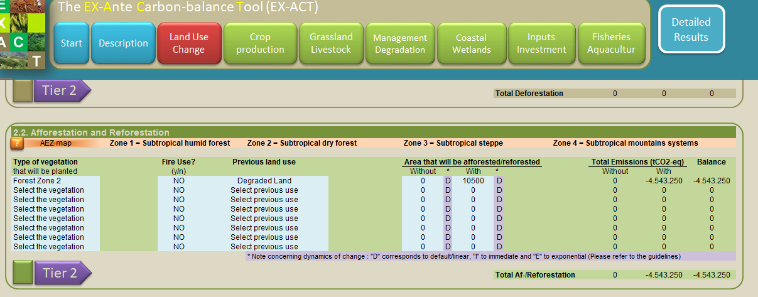
Figure 2. Avoided emissions coming from Land Use Change (afforestation/reforestation activities).
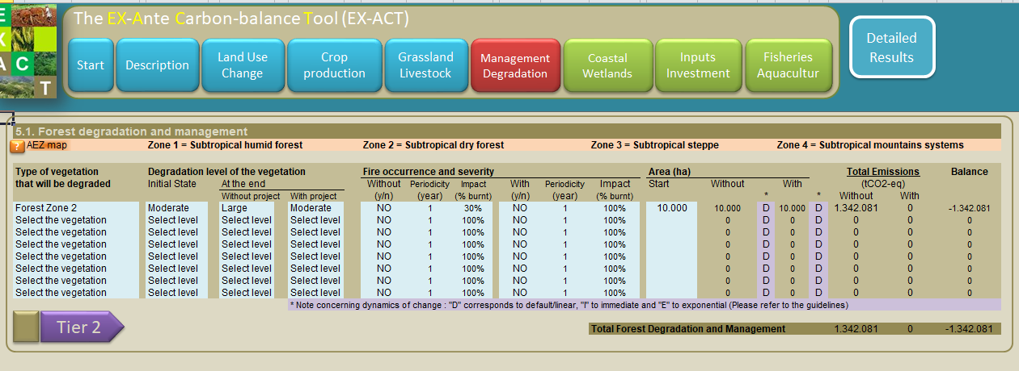
Figure 3. Avoided emissions coming from Management Degradation.
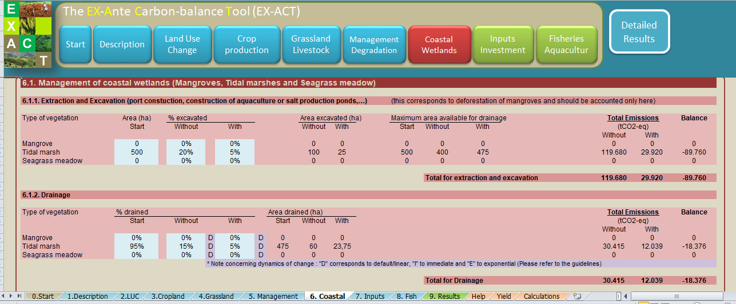
Figure 4. Avoided emissions coming from coastal wetland sustainable management.

Based on these computations, the annual net emissions avoided will be 299,673 tCO2e. Over a 20-year period, total carbon emission savings will amount to 5,993,467 tCO2e (see detailed results in Figure 5)
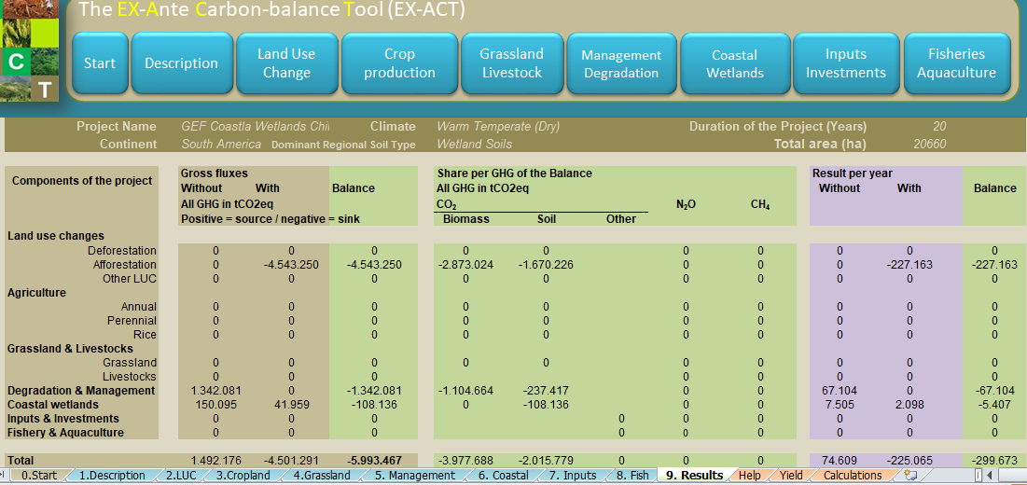
Figure 5. Detailed results showing carbon emission savings for Coastal Wetlands Project over a 20-year period.

See some of the publications that have made use of the Ex-Ante tool here.

